[4. Technical Feasibility: Explain the technical design of your solution. How does your prototype work? What are its limitations? Are there any technical hurdles or problems that need to be solved in order to build a real network based on your prototype?] (5000 words or fewer)

4. Technical Feasibility: Our BarelasGig working prototype uses a modern wireless millimeter wave (mmwave) backhaul/transport link to deliver wireless multi-gigabit broadband into the heart of the underserved community of Barelas. As shown in Figure 1, this backhaul link has a fiber feed from the roof of the three story BigByte.cc Data Center at 123 Central Avenue NW. From there the signal is beamed via a 2.5G antenna/radio 0.3 miles south to a jump comprised of two 2.5G antenna/radios on a tall tower atop of the two story Side Track Brewery building at 413 2nd Street SW. From this jump the signal is beamed 0.7 miles further south to a 2.5G antenna/radio on top of the two story Albuquerque Hispano Chamber of Commerce building (AHCC) at 1309 4th Street SW. From that AHCC access point broadband connectivity is radiated 0.8 miles over 360 degrees from a 10G Omni antenna/radio. This prototype is now working, delivering broadband connectivity into the heart of the Barelas.

Fiber and microwave deployments have been successfully used for decades to deliver commercial connections. However, traditional microwave is not ideal for high speed internet in dense urban environments. Line of sight communications, frequency coordination, interference management, and electromagnetic field concerns complicate and challenge microwave based designs. Ultimately, traditional microwave’s limited spectrum does not have the required bandwidth to deliver high speed broadband internet. Fiber, on the other hand, provides the bandwidth to deliver high speed broadband internet but it is costly and complicated to install.

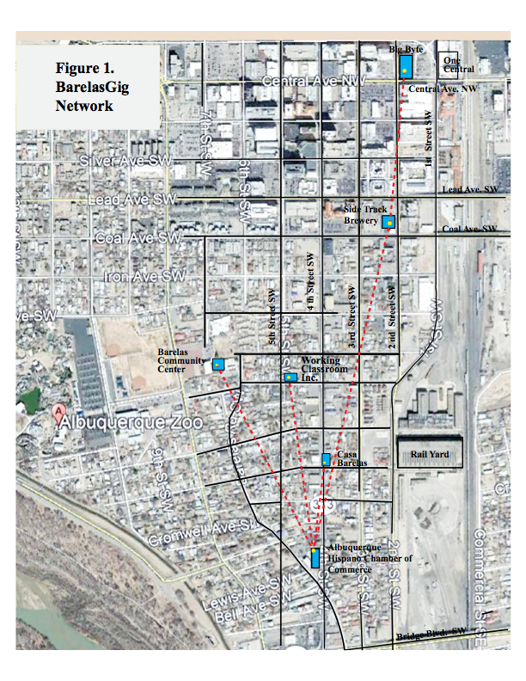The problems associated with fiber and microwave have been overcome by modern mmwave technology, available from several suppliers. AbqGig has selected the patented MetroLinq mmwave technology from IgniteNet of Irvine, CA, due to its superior performance and reasonable cost for this project. The MetroLinq technology provides sufficient spectrum in the 60GHz band to deliver 10Gbps speeds in urban environments, license free, without interference from other frequency bands. It is readily deployable on roof tops, towers, existing power poles and light poles. Low cost point to point (PTP) and point to multi point (PTMP) connections over distances of 1.5 miles (2500 km) from fiber feed points are common.

Mmwave technology is not new but has been avoided in the past due to rain sensitivity and cost. Combating rain fade, IgniteNet’s MetroLinq 60Ghz radios have built in redundancy with lower band backup failover 5GHz radios to ensure there is always a robust connection even in inclement weather. Lower costs make this robust technology highly competitive. Also, research preparing the way for Smart Cities with 5G connectivity is pointing toward such modern wireless mmwave technology to deliver the bandwidth for the multi-gigabit speeds needed.[1]

As mentioned in Section 2, the AbqGig goal is to ultimately utilize the low cost fiber feed from the City of Albuquerque’s affordable public access Central Avenue optical fiber backbone. However, that fiber feed may not be available for another six months or so. In the meantime, the BigByte Data Center on Central Avenue is generously providing free fiber feed for our working prototype, which beams a gigabit broadband signal into the access point at the AHCC in the heart of the Barelas neighborhood. From this access point, additional PTP and PTMP connections are built out providing the neighborhood true high speed wireless broadband service.

In more detail, the BarelasGig working prototype uses an IgniteNet MetroLinq 2.5G 60-35 ($562) antenna with radios in the 60GHz and 5GHz backup frequencies to beam the broadband signal at up to 2.5Gbps into Barelas. This focused antenna sends and receives the primary backhaul signal line-of-sight at 60GHz and provides failover backup non-line-of-sight at 5GHz in the harshest weather conditions. These antenna/radios are interference free and license-free. The path from atop BigByte to a 60 foot tall tower atop the Side Track Brewery building, has clear line of sight 0.3 miles (480 m) south with no obstructions. Near the top of this tower two MetroLinq 2.5G 60-35 antenna/radios are mounted to provide a jump to receive and send the primary backhaul signal on 0.7 miles (1127 m) to a 2.5G 60-35 antenna/radio at AHCC. From this high tower there is clear line-of-sight south to AHCC. These radios allow for monitoring, local or remote cloud control and Trill enabling for the system.

At AHCC the backhaul signal is coupled to a MetroLinq 10G Tri-Band Omni antenna ($939) housing radios at 60 GHz, 5GHz, and 2.4 GHz. The 60GHz radio delivers up to 10Gbps transport line-of-sight, the 5GHz radio provides non-line-of-sight back up for reliable high throughput in the harshest weather conditions, and wireless internet access and WiFi for the surrounding area is provided non-line-of-sight at both 5Ghz and 2.4GHz. The Tri-Band Omni provides 360 degrees of network connectivity up to a 0.43 mile (700m) radius for 24 users on 60GHz, 50 fixed access users and up to 256 WiFi devices on 5GHz, plus up to 256 WiFi devices on 2.4GHz. Thus, there can be 586 simultaneous users within the area enabling customizable access for local businesses, residents, police, emergency responders, tele-medicine and future Smart City needs.

At the tower and at AHCC managed MeshLinq Switches are added to connect the radios, provide internet and WiFi access, and allow the network to grow including adding redundant paths for a self-healing network. Specification sheets for the MetroLinq equipment are shown in the linked information.

This BarelasGig robust, reliable high speed backhaul provides 2.5Gbps from BigByte one mile south into the heart of Barelas at the AHCC. Internet access and WiFi will be provide at AHCC and at the Barelas Community Coalition, which is located in the same building at 1309 4th Street SW. AHCC will serve as the anchor for additional sites with PTP or PTMP connections.

From this anchor access point at AHCC the signal is beamed north 0.2 miles (320 m) to a ML 2.5G 60-19 antenna/radio ($499) at Casa Barelas, where it will provide up to 2.5GHz broadband at 60GHz and 5 GHz. Additional sites will be added to expand the network to homes and businesses as funds become available. This design, provides the neighborhood with up to 2.5Gbps broadband service making it safer and prepared for future Smart City needs.

In Figure 2, a radio frequency map of the BaralesGig Network is shown. This RF Map is a design tool that shows the real RF coverage for different client equipment options. This map was provided by ??, an independent contractor provided by IgniteNet, to help illustrate the real world performance of their equipment. The effect of trees, buildings or other obstructions is taken into account. A 10G Tri-Band Omni radio, which is planned for the future on the Side Track tower, is assumed to be installed there as well as at the AHCC. In this Figure 2 example the clients are assumed to have dual-band ML 2.5G 60-19 radios with 0.25 mile (400 m) range from the Omni.

The clients in the red areas are receiving 100% of the assumed 2.5Gbps available bandwidth. The clients in the yellow areas are receiving 1Gbps, the clients in the blue areas are receiving 300Mbps, the clients in the grey areas are receiving no signal due to trees, buildings or some other blockage. The void areas where no color is seen are out of range and receive no signal. It is evident that the 10G Omni radio mounted on the 60 foot tall tower at Sidetrack has significantly better coverage than the Omni on the 30 foot mount at AHCC. It is also evident that the Omni radios provide excellent 360 degree coverage. It is also evident that the Barelas Community Center is slightly out of range if they have the ML 2.5G 60-19 radio; thus they should have a ML 2.5G 60-35 radio which has a 0.43 mile (700 m) range from the Omni.

The technical feasibility of the BarelasGig network is excellent. It is up and running. There are no known technical hurdles to be overcome.

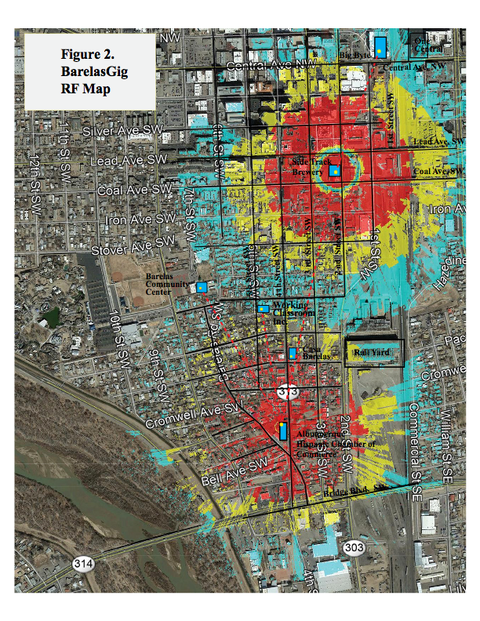Size: 1420 words/5,000 allowed

1. Will Millimeter Waves Maximize 5G Wireless?, Scientific American, June 23, 2015.